
Company
Logotype

Cone Beam Computed Tomography- Report



Porur Dental X-rays & CBCT

Patient Name : Mr. Manikandan | Date of Report : 22.02.2025
Age/ Gender : 25 years/ Male | Region of Interest : CBCT Maxilla
Referring doctor: Dr. Subramoniam | Indication : fracture 11,12,21,22?
Clinical Notes: Nil
PATIENT INFORMATION

CBCT Maxilla provided
CBCT – IMAGE DETAILS

RADIOGRAPHIC INTERPRETATION

- In relation to the periapical aspect of 21, presence of a single, expansile, unilocular, hypodense area bounded by a corticated margin measuring 7.3 x 12.61 x 9.89 mm in dimension.
- The hypodense region appears to be in contact with the apical portion of 22 and appears to cause extreme thinning of palatal cortical bone and loss of labial cortical bone.
- The hypodense area is at a distance of 6.3 mm from the floor of nasal cavity.
- Mucosal thickening in relation to the floor of the left maxillary sinus is evident.

RADIOGRAPHIC IMPRESSION

- Differential Diagnosis (based on the visible radiological features): Periapical pathology in relation to 21 suggestive of Radicular cyst.
- Left Maxillary sinusitis.


Kindly correlate with clinical and histopathological features

IMAGES FOR REFERENCE

RECONSTRUCTED PANORAMIC VIEW

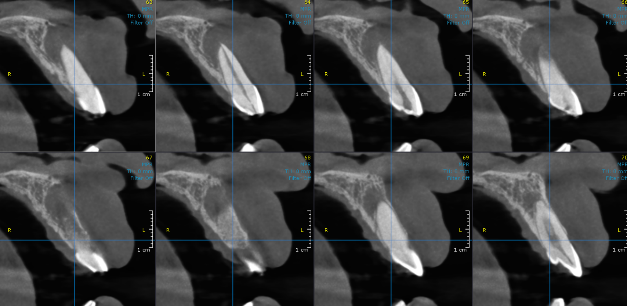
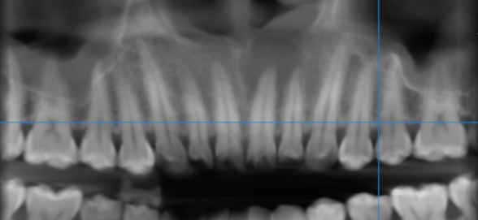
CROSS SECTIONAL IMAGES FOR REFERENCE

3-DIMENSIONAL VIEW

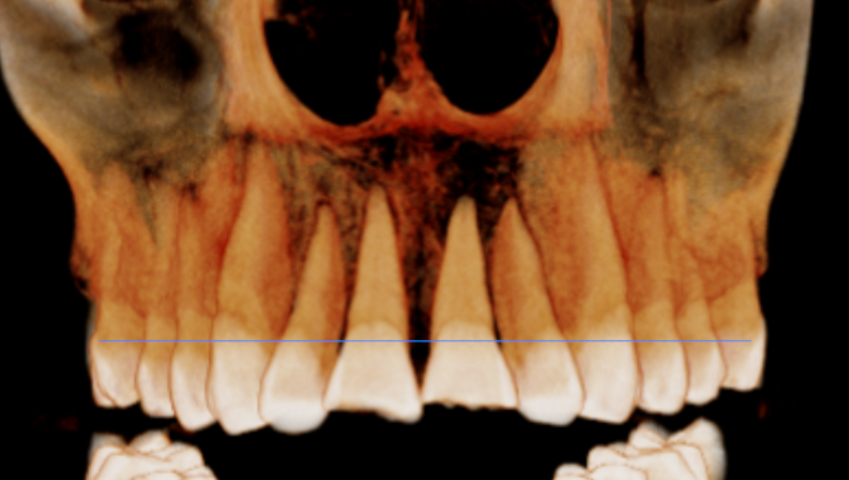

**** End of report ****

